Client Session Tools:

Using an Ecomap

Introduction
An ecomap is a tool that social workers and others in the helping professions can use when working with individuals or families in a counseling setting.
Ecomaps are draw from Systems Theory and can be used during a session to help clients see the different systems influencing their family or themselves.

Family Video
Narrator
Karen and Sam are newlyweds. Karen has two adolescent children, Angie and Casey, from a previous marriage. Sam also has a child, Tommy, who is younger than the girls. All five live together in small, overcrowded apartment. Instead of The Brady Bunch, Karen and Sam's family is not quite ready for prime time.
Sam is worried about his son Tommy. Karen's children regularly pick on their smaller step-brother and Karen lets things get out of hand. She tells Sam that the kids just need to learn how to get along. Sam feels frustrated that he can't get through to Karen's children. They don't respect him and he can't discipline them.
Karen's mother accuses Sam of being mean to the girls. The girls have learned to manipulate the situation by creating a scene. They run and cry to their mom, who finally restores order.
Karen intentionally waits for everything to explode before she steps in. In this way, she asserts herself as the dominant figure in the household—and then resents having to be in charge. She's angry with her husband for regularly coming home late. She feels that when he does get home he avoids the ongoing family squabbles by heading straight to the computer. She's playing the hostile-martyr role.
Karen sees herself as the victim in the family. She thinks that she's being the perfect mother and wife. She assumes all of the responsibility for fixing all of her family's situations. She thinks Sam is being insensitive and neglectful of her. Sam, in turn, resents her behavior. Her destructive behaviors are designed to make her look good, and him look bad. The result, however, is that she has become the target of her husband's resentment.
Casey and Tommy have been getting into trouble at school. They've been getting into fights with other students and acting out in the classroom. This has caught the attention of the middle school counselor. Tommy has admitted to the counselor that he has had thoughts of hurting himself and others. Tommy feels ganged-up on at home and feels that his family blames him for everything.

Family counseling session
Human Services Professional (HSP)
Welcome. I am Dennis. So you must be the Tates.
Karen
Um, yeah. I am Karen and this is my husband Sam. And our children Casey and Angie; and that is my stepson, Tommy.
HSP
Well, I just want you to know I work a lot with families. This is a confidential and private setting. So you are able to speak freely.
Karen
Well, I have to be honest. I have very mixed feelings about this whole deal. I think that we are just like any other family, and we have our issues – but I don't think we need professional help. It is not like we neglect the kids, or anything.
HSP
I appreciate your honesty and your openness. I just want you to know that I can appreciate that families today are under a lot of stress with money issues and cultural shifts going on. It is not like I was in our generation (looks at dad) and I want you to know I understand that.
Sam
You can say that again. When I was growing up, loyalty was really important. I remember my dad worked for the same company for 30 years. Back then companies were loyal to employees and employees were loyal back. Those were the good old days.
HSP
From what I understand, Tommy here was referred to me by Ms. Kilgore, at the CyLinks Middle School. So Tommy, tell me, what is going on in school that is bothering you?
Tommy
Well, I am tired of getting picked on. It is a new school so I do not know a lot of people yet. Everyone calls me names, and they think I am stupid. It is tough because even when I try to make friends it just does not work. I never get picked for teams in gym—and it just seems like nobody likes me.
HSP
Well, what about at home? What worries you at home?
Tommy
The place we live in, our apartment, it's pretty small. My sisters, have themselves to talk to and they do not include me. Then they hog the computer so I never get a turn— and then when I want a turn they always call me names or do mean stuff.
HSP
Tommy, what do you do that bothers your sisters?
Tommy
Nothing. They do everything. They…
HSP
Wait a minute, wait a minute (to Karen and daughters) Go on (to Tommy).
Tommy
OK. It just seems like no one likes me at home except for my dad, and he is at work most of time. My stepmom is busy cleaning or doing other things—and it just seems like no one has time for me. I wish things would go back to normal—just me and my dad.
HSP
Well, adjusting to, new family, new school, new rules—this can be stressful for anybody.
Karen
Now wait a minute. I am doing my best that I can for everybody here. I mean, I get the kids up, I am making sure you are dressed (look at girls), I volunteer. Then I am helping grandma—I take care of grandma, I am cooking, doing dishes and I am helping you with homework every day. You know, give me a break! I am the one who is alone here. And when he comes home, I mean, Sam does not help out much. (Looks at Sam, whispers) Well you do not.
HSP
(Look toward Casey and Angie) You guys are teen-agers, right? Could you possibly get up in the morning by yourselves?
Casey
I suppose we could do it ourselves but she likes to do it. It is just easier for me—well, for us—if she does it. My stepdad is always nagging us about helping out mom more but I am busy with friends, and school and MySpace and my softball team. I am hitting .450.
Angie
When I get home I just want to chillax before getting to my homework. I am really worried about college and I have a ton of hard classes. I have Algebra and Chemistry, and five other.
HSP
Um, Chillax?
Angie
Chill and Relax.
HSP
OK, I got it. Sam, What are your thoughts?
Sam
I am just trying to do right by my family, like my dad did for me. You know I did not have a great relationship with my dad, so I am really trying to be here for Tommy. (pause) and for Karen, and Casey and Angie too. And let us not forget I work 60 hours a week. Everybody criticizes me but they forget that I am the man of the house. Am I supposed to work and come home dead-tired and do all this work too? It seems like all I am doing lately is putting out fires between the kids. It just seems to me that Karen is so much better at talking to, listening to and relating to the kids. With me, it is different. The girls: they just do not even like or respect me.
HSP
Well, I agree that families working together can be a challenge but it is important for everybody. All families have their stressors, you know, things that cause stress, uncertainty and conflicts in relationships. Let us take a moment to look at this session not as a "Who's to blame," but more as a problem-solving session. Things are different now than they were for our parents or our grandparents. So what we are going to do is we are going to take a look at an ecomap and it is a tool that we can use to examine some of the stressors, conflicts, different things like that within relationships. How does that sound as a plan for the day?

Family Ecomap
The ecomap is a visual illustration of a family's relationships and stressors in the family's environment. The visual model can increase awareness of the multiple social factors in a client's environmental system.
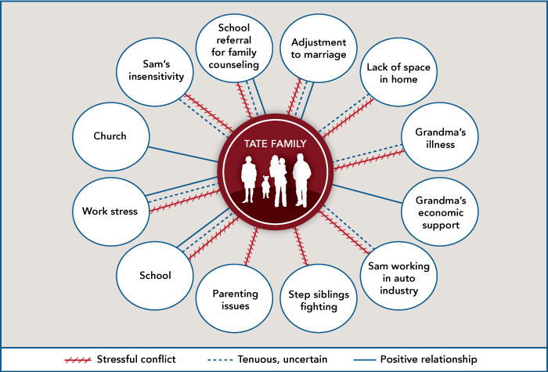
The individual or family is represented at the center of the circle and family connections are shown. Around the circle are the systems that are a part of the client(s)'s life. The nature of the connections is shown by the lines used to connect them to the person or family unit. Thicker lines show a stronger relationship, while curvy or red lines indicate a stressful relationship. Arrows pointing to the clients show that the system tends to influence the client and arrows pointing to the system mean that the client tends to influence it. Arrows pointing in both directions show that influence goes both ways.

